**DOCKER DOCUMENT**

Step:1 pulling the docker image named ubuntu from dockerhub

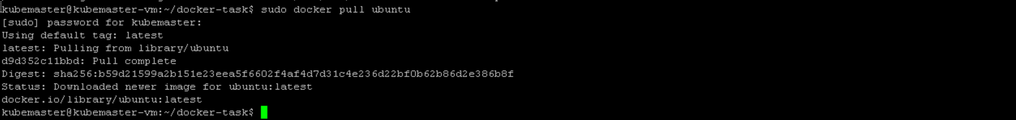

Verifying the ubuntu image using docker images command



Creating and running the docker container in detach mode:



Verifying the container:



**Verification of containers system resources can be done using**

Docker exec -it <container-id> -- /bin/bash

Then after getting into it we can check resources such as

Ubuntu -–version

Du -h -disk usage , free , top command to check usage

Due to some issues im unable to get into it



**Stopping and cleaning up the container**

